Add Policy

**#1**

* *Name – Life Insurance*
* *Company Name- Liberty*
* *Company ID – CO0001*
* *Company Address – SKAV 5, Richmond circle, Richmond*
* *Key Contact Name – Akash Nair*
* *Key Contact Number - 8031996007*
* *Company Email Address – life@libertymutual.com*
* *License Registration Date – 06/01/2018*
* *License Period – 6 months*
* *License Expiry Date -12/01/2018*

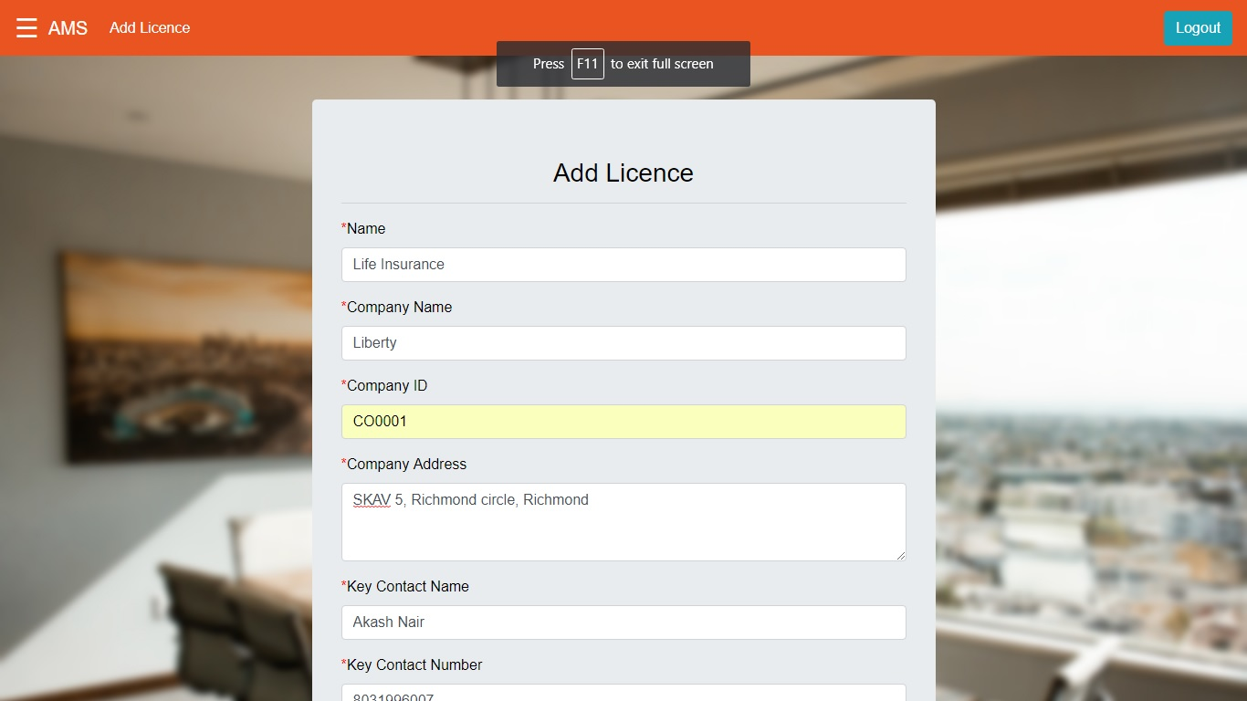

Output:

*Successful*

*Policy with ID PO0001 has been successfully registered!*

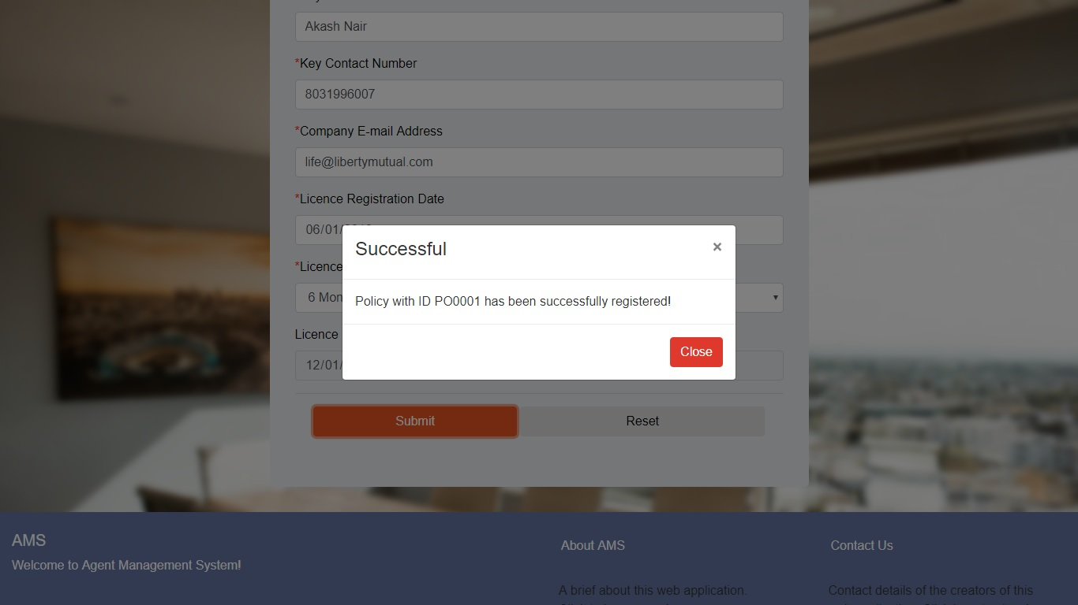

**#2**

* *Name – Vehicle Insurance*
* *Company Name- ICICI*
* *Company ID – CO0002*
* *Company Address – ICICI HQ, Mumbai*
* *Key Contact Name – Chitra Kochaar*
* *Key Contact Number - 7878765678*
* *Company Email Address – vehicle@icici.com*
* *License Registration Date – 06/27/2018*
* *License Period – 6 months*
* *License Expiry Date -06/27/2019*

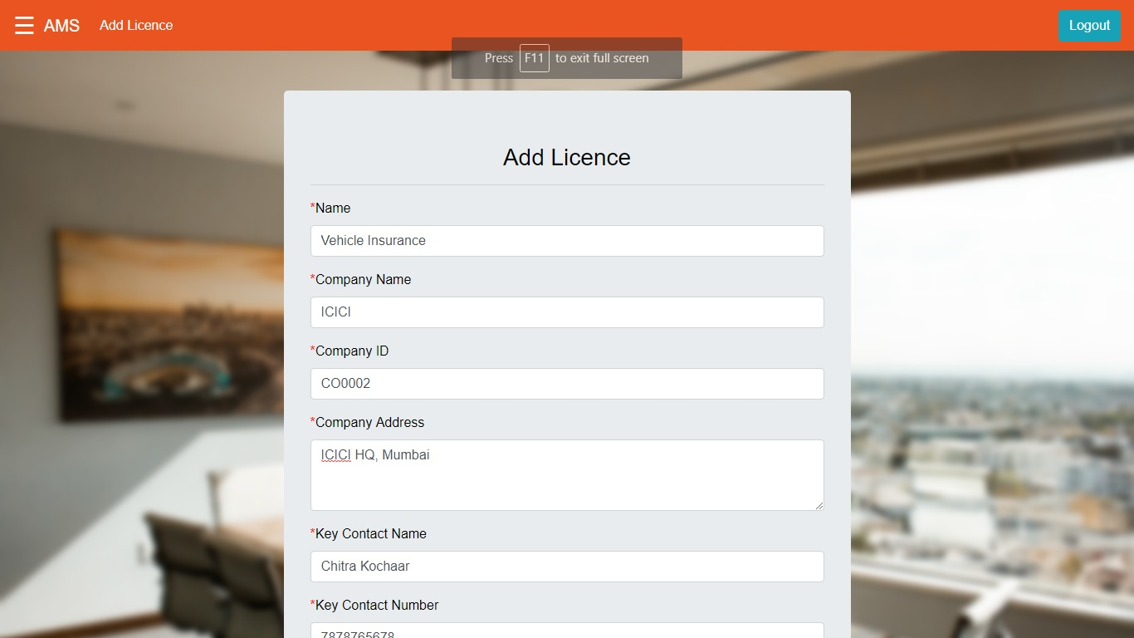

Output:

*Successful*

*Policy with ID PO0001 has been successfully registered!*

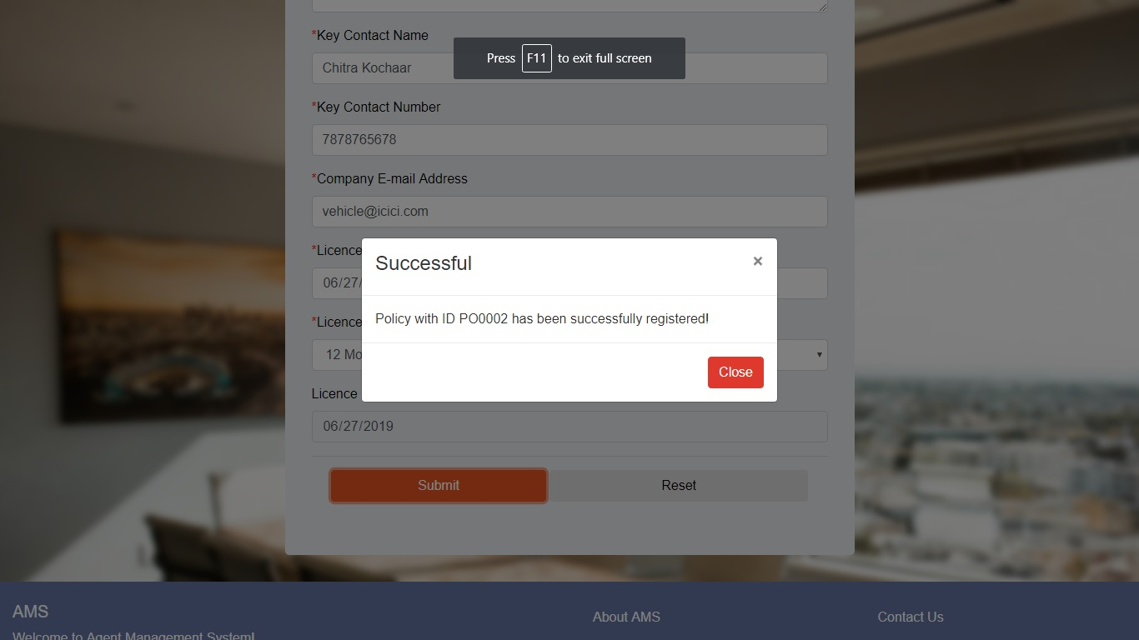

**#3**

* *Name – Health Insurance*
* *Company Name- Max Life*
* *Company ID – CO0003*
* *Company Address – Max Life HQ, Delhi*
* *Key Contact Name – James Jones*
* *Key Contact Number - 9098987656*
* *Company Email Address – health@max.com*
* *License Registration Date – 06/27/2014*
* *License Period – 6 months*
* *License Expiry Date -12/27/2014*

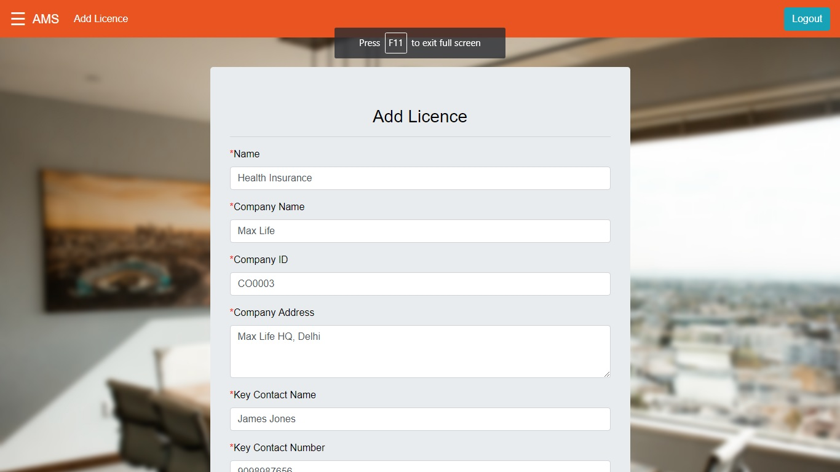

Output:

*Successful*

*Policy with ID PO0003 has been successfully registered!*



**#4**

* Name – Property Insurance
* *Company Name- ICICI*
* *Company ID – CO002*
* *Company Address – ICICI HQ, Mumbai*
* *Key Contact Name – Chitra Kochaar*
* *Key Contact Number - 7878765678*
* *Company Email Address – vehicle@icicicom*
* *License Registration Date – 06/15/2011*
* *License Period – 16 months*
* *License Expiry Date -12/15/2012*

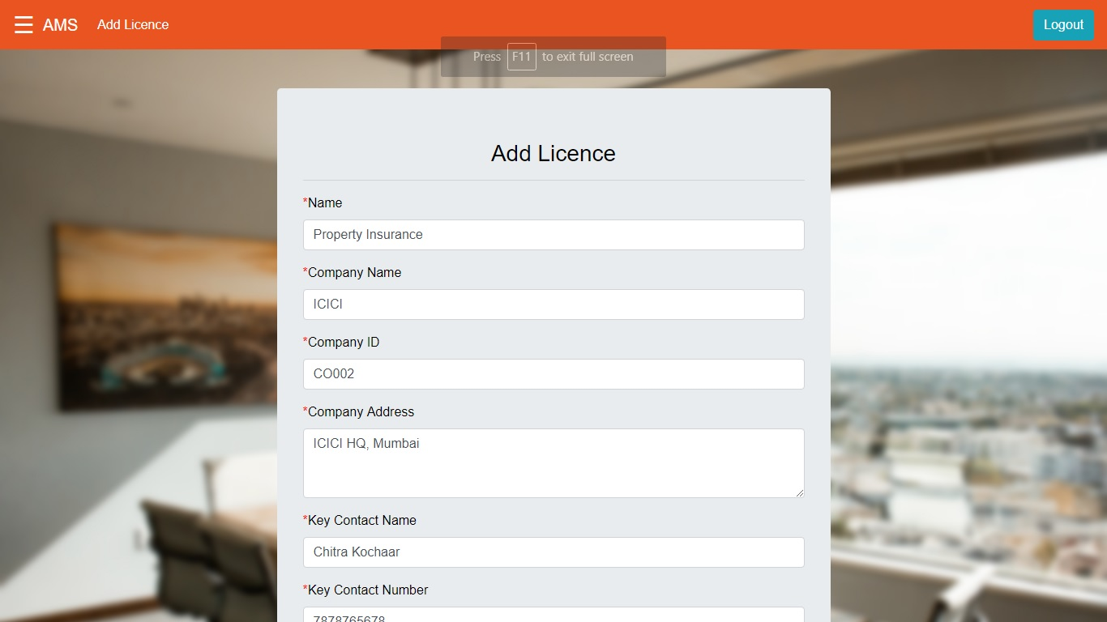

Output:

*The following tooltips appear beside each respective field:*

*Company ID should start with CO and be followed by 4 digits*

*Please enter a valid email address*

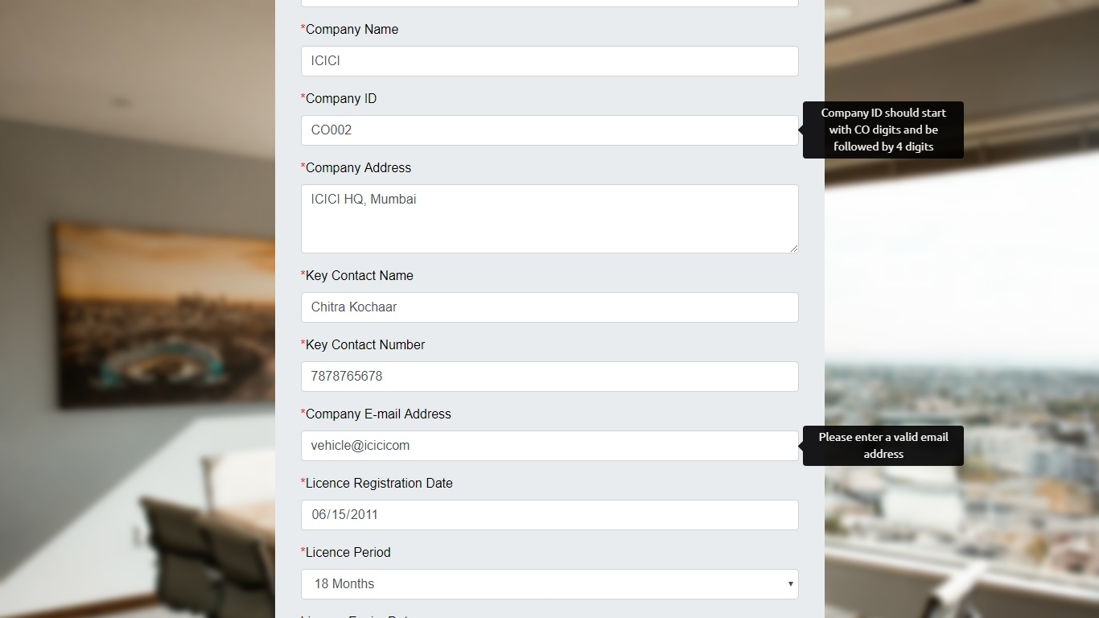

**#5**

* *Name – Property Insurance*
* *Company Name- ICICI*
* *Company ID – CO002*
* *Company Address – ICICI HQ, Mumbai*
* *Key Contact Name – Chitra Kochaar*
* *Key Contact Number - 7878765678*
* *Company Email Address – vehicle@icici.com*
* *License Registration Date – 06/15/2011*
* *License Period – 16 months*
* *License Expiry Date -12/15/2012*

Output:

*Successful*

*Policy with ID PO0004 has been successful registered!*

